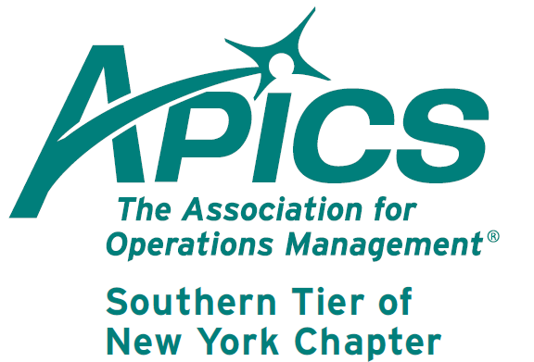
Notice New Name →→
←←Notice New Name
www.stapics.org

MEMBER APPRECIATION NIGHT

Friday, June 15, 2012

Location: NYSEG Stadium
Binghamton, NY

Join us at NYSEG Stadium for an evening of BMets Baseball. Binghamton Mets vs Altoona Curve.

We have box seats reserved for you and your guest(s).

Tickets are just $10 for box seat and voucher good for a hot dog and a soft drink. (Total $16 value)

Advance payment required no later than Friday, June 8th.

Contact Mike LoSapio for details: 607-786-3487 or email at Michael.losapio@synergyresources.net.

Mail Payment to:
Michael LoSapio
2714 Plaza Drive
Endwell, NY 13760

Longevity Award!

Pearls to these chapter members for maintaining their APICS memberships for over30 years!

Janet Lafayette – 34 years
Don Sheldon – 34 years
Mike LoSapio – 33 years
Douglas Creamer – 31 years

They know the value of APICS. Congratulations, and we hope to keep you as members for another 30+ years!



Confess – you’ve always wanted to join the Southern Tier of NY chapter of APICS Board of Directors!

Admit it – it’s one of your private fantasies!

You’ve always secretly desired to have a say in the administration of your local APICS chapter. Well, now, your wishes can come true! Attend our next Board of Directors meeting on June 6, or contact any member of the board. Come and join the Board, and we will satisfy your secret craving!



We’re on !!!
Come and visit, poke around, or comment on us! Our name there is “Southern Tier APICS”. It’s just another way
for us to keep in touch with our membership.

Board of Directors 2011-2012

President Director of Publicity
Dave Gardner Kelly Norieka
dgardner@squaredealinc.com Kelly.norieka@lmco.com

Executive VP /Director of Finance Director of Education
Steve Whited Don Sheldon
sjw6@meadwestvaco.com dsheldon@sheldoninc.com

Secretary Director at Large
Debbie Unkel Steve Stanchak
deb.unkel@raymondcorp.com steve.stanchak@infoprint.com

Director of Membership/Director of Chapter Standards/

Director of Online Publication Director of Student Relations
Lee Schechter Brian Arrnold
lschechter@stny.rr.com barnold@amphenol-aao.com

Director of Programming and Marketing Director of Communications
Michael LoSapio April McWeeney
Michael.LoSapio@SynergyResources.net april.mcweeney@mwv.com

Southern Tier APICS
PO Box 1107
Binghamton NY 13902-1107

